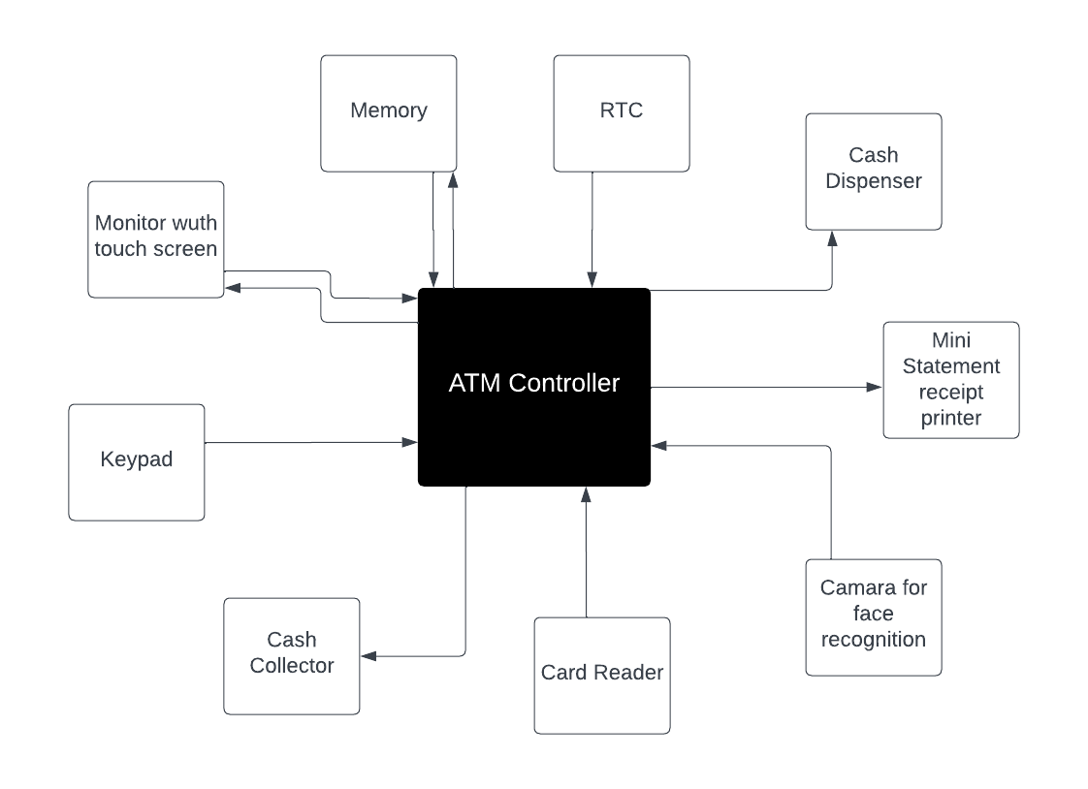

MODEL BLOCK DIAGRAM